**Analytics for Capital Projects and Bond & Levy Sections**

Capital Project for September 1, 2017 to January 10, 2018

**Page views** (the number of times the page was opened

Friendly URL (capitalprojects) 2295  
By domain identifier 2107  
By page identifier 2511  
_______________________________  
Total 6813

**Unique page views** (number of sessions during which the page was opened)

Friendly URL (capitalprojects) 892  
By domain identifier 799  
By page identifier 740  
_______________________________  
Total 2431

The above means in 2431 individual session the page was views 6813 times.

**Average time on page**

Friendly URL (capitalprojects) 00:00:20  
By domain identifier 00:00:23  
By page identifier 00:00:34  
__________________________________  
Average time 00:00:26

There is a **bounce rate** of 0 which means everyone who entered our website through this page went on to view other pages on the website.

Friendly URL

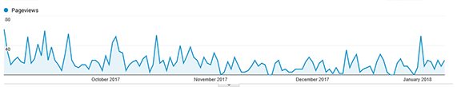

Domain identifier

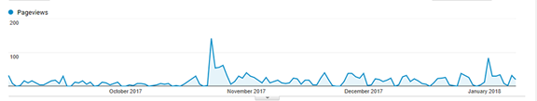

Page identifier

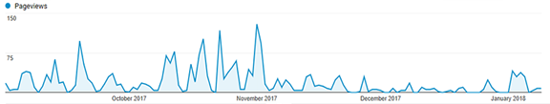

Bond and Levy January 2, 2018-January 10, 2018 (site was not available until then)

**Page views**

Friendly URL (2018bondlevy) 90  
By page identifier 62  
_______________________________  
Total 152

**Unique page views**

Friendly URL (2018bondlevy) 40  
By page identifier 15  
_______________________________  
Total 55

**Average time on page**

Friendly URL (2018bondlevy) 00:00:55  
By page identifier 00:00:43  
__________________________________  
Average time 00:00:50

**Bounce rate** 0